**Day 2 Lab Assignments**

1- Make a page that contains login form contains user name and password (Use Bootstrap forms), and on user Name input, when the user leaves the input check for the length of the entered text if less than 5 letters, show a bootstrap alert below the input saying “Name should be more than 5 letters” and when the text is valid close the alert.

2- Make simple Bootstrap page, and implement the following(Optional, if you can start with the following assignments):

* 1. Try Container and container-fluid.
  2. Try navbar
  3. Try Bootstrap icons
  4. Try any Bootstrap classes and components you need to try.

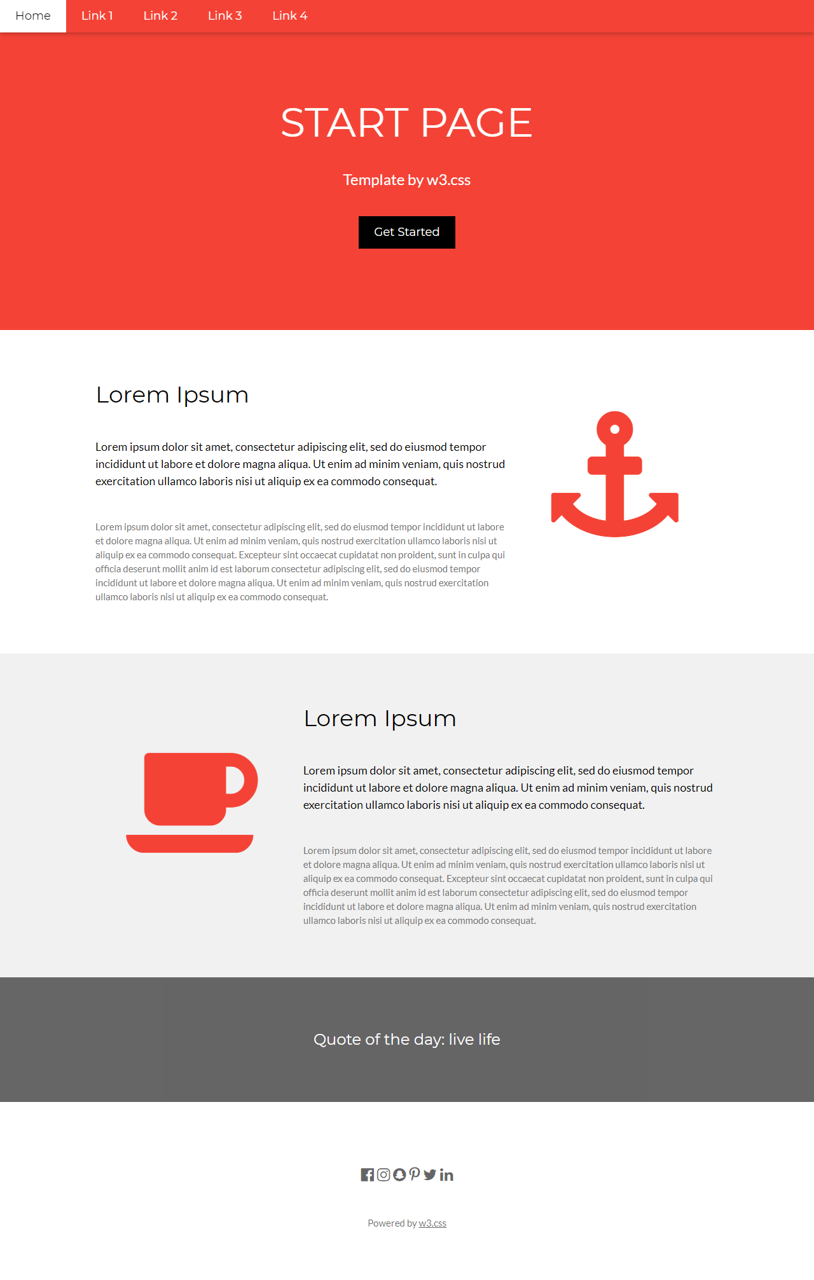

3-Design the following social media website template using Bootstrap:

a. Make the navbar fixed and collapsible.

b. Handle the layout of left, right and middle content to be columns 3,7,2 on the large and bigger screen, and to be columns 2,8,2 on the medium and smaller screens.

c. Hide the right column in extra small screen.

